TASK SHEET
Foundation English
Topic: Mock EST Task 4

Topic:

Student: Teacher: Date Due: Term 2

Achievement Standards:
Receptive Modes: (reading, writing)
Productive Modes: (writing, creating)
Achievement Standard focused on:
- Reading
Time allocation: 2 periods
Conditions: In class completion of a mock EST style response

Weighting: 7.5%

Mark: / 100

Teacher Comment:

Task
There are two parts to this test. Answer all questions in the booklet.
Part A
Read the article and answer questions 1 - 3
Part B
Create a PowerPoint presentation containing 3-5 slides for year 11 and 12 students called, ‘Why you should think about your smartphone use.’

Self-reflection
What three things did I do well?
What three things could I have done better?
What things could I do in class to help me improve for the next task?
What things could I do at home to help me improve for the next task?

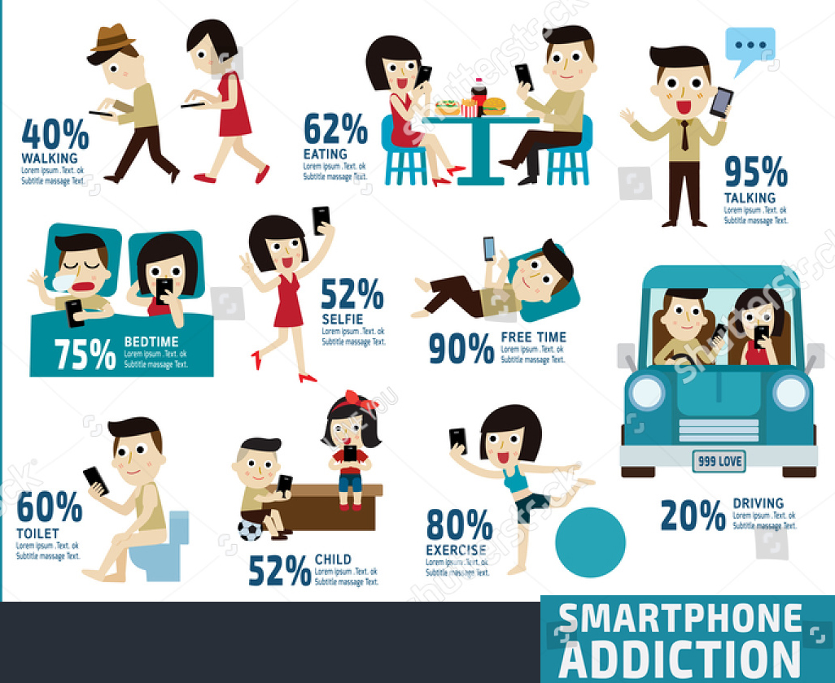
Part A: Read the article and answer questions 1 - 3
Are you addicted to your smartphone?
Obsessively checking our smartphone apps may look like addiction but, for most people, it is reinforced behaviour that could be broken without severe or long-lasting withdrawal effects.
The term “addiction” is often bandied about when we think someone spends too much time on something we deem detrimental to their health and well-being. From checking our phones repetitively, to playing with specific apps and texting, the modern culprit is excessive smartphone use.
Worldwide, more than two billion people own smartphones and the average user checks their phone 85 times a day.
Obsessively checking our smartphone apps may look like addiction but, for most people, it is reinforced behaviour that could be broken without severe or long-lasting withdrawal effects.
In 2013, the fifth edition of the Diagnostic and Statistical Manual of Mental Disorders (known as the “clinician’s bible”) introduced wider criteria for “behavioural addictions”, which doesn’t include the physical dependence element. These are compulsions to engage in a task or act that leads to psychological pleasure.
Both “substance” and “behavioural” addictions impact the way we process information. Over time, the brain rewires itself to seek out the reward it needs to gain pleasure or relief from stress. The more an addict seeks a specific reward that triggers both dopamine and other physiological effects (such as stress and pain relief), the more the brain decreases sensitivity to the reward circuits.
To date, smartphone use has not led to mass accounts of severe mental dysfunction. So we’re unlikely to all be “addicted” to our smartphones, as we often tell each other.
Question 1
- What are two kinds of addiction mentioned in the article?

- List two items of information in the article that would be relevant to high school students.

Question 2
Identify a technique (written or visual) that the writer uses to capture the interest of the reader. Give an example from the article and explain the effect.

Question 3
How often does the average smartphone user check their phone?

Part B
Create a PowerPoint presentation containing 3-5 slides for year 11 and 12 students called, ‘Why you should think about your smartphone use.’
You may use some of the information from the article and some of your own ideas.
Consider:
- Words and phrases you will use to present information.
- Illustrations graphs or diagrams you will use.
- The layout you will use to make the information clear and appealing.

